PN 25/40 | STANDARDNA IZVEDBA  STANDARD DESIGN
KUĆIŠTE  BODY | GS-C25/ W.Nr. 1.0619  CAST STEEL GP240GH
UNUTARNJI DIJELOVI  INNER PARTS | NEHRĐAJUĆI ČELIK  STAINLESS STEEL
NAZIVNI OTVOR  NOMINAL DIAMETER | DN 15-200
NAZIVNI TLAK (bar)  NOMINAL PRESSURE | PN 25/40
TEMPERATURA  TEMPERATURE RANGE | DO 400⁰C  TO 400⁰C
SPAJANJE  CONNECTION | PRIRUBNICA DIN 2501  FLANGES

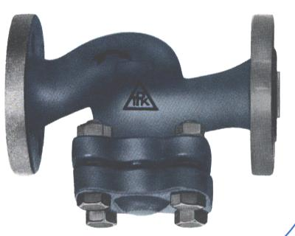

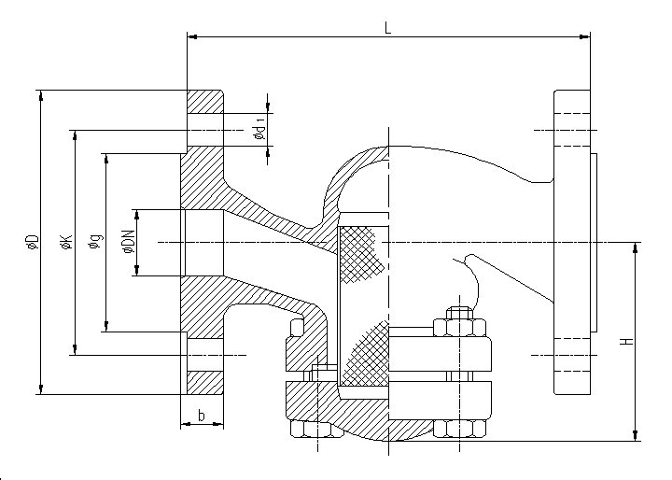

NAMJENA: VODA, PARA, ZRAK, INERTNI PLINOVI.

CONTENTS: WATER, STEAM, AIR, INERT GASES.

DN | L  25/40 | H  25/40 | øD  25/40 | øK  25/40 | ød₁  25/40 | n
15 | 130 | 76 | 95 | 65 | 14 | 4
20 | 150 | 82 | 105 | 75 | 14 | 4
25 | 160 | 85 | 115 | 85 | 14 | 4
32 | 180 | 100 | 140 | 100 | 18 | 4
40 | 200 | 105 | 150 | 110 | 18 | 4
50 | 230 | 110 | 165 | 125 | 18 | 4
65 | 290 | 132 | 185 | 145 | 18 | 8
80 | 310 | 145 | 200 | 160 | 18 | 8
100 | 350 | 168 | 235 | 190 | 22 | 8
125 | 400 | 198 | 270 | 220 | 26 | 8
150 | 480 | 217 | 300 | 250 | 26 | 8
200 | 600 | 267 | 360/375 | 310/320 | 26/30 | 12

