PN 6 | STANDARDNA IZVEDBA  STANDARD DESIGN
KUĆIŠTE  BODY |  | GG-25/ W.Nr. 0.6025  CAST IRON EN-JL 1040
UNUTARNJI DIJELOVI  INNER PARTS |  | NEHRĐAJUĆI ČELIK  STAINLESS STEEL
NAZIVNI OTVOR  NOMINAL DIAMETER |  | DN 15-200
NAZIVNI TLAK (bar)  NOMINAL PRESSURE |  | PN 6
TEMPERATURA  TEMPERATURE RANGE |  | DO 300⁰C  TO 300⁰C
SPAJANJE  CONNECTION |  | PRIRUBNICA DIN 2501  FLANGES
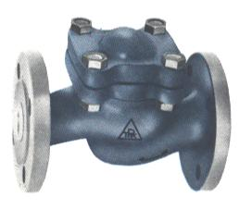

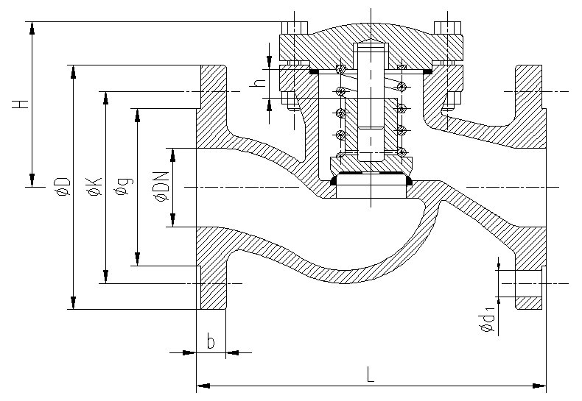
NAMJENA: VODA, PARA, ZRAK, INERTNI PLINOVI.

CONTENTS: WATER, STEAM, AIR, INERT GASES.

DN | L | H | øD | øK | ød₁ | n | masa  weight  kg
15 | 130 | 65 | 80 | 55 | 11 | 4 | 2,9
20 | 150 | 65 | 90 | 65 | 11 | 4 | 3,5
25 | 160 | 77 | 100 | 75 | 11 | 4 | 4,3
32 | 180 | 77 | 120 | 90 | 14 | 4 | 5,6
40 | 200 | 100 | 130 | 100 | 14 | 4 | 8
50 | 230 | 100 | 140 | 110 | 14 | 4 | 10
65 | 290 | 117 | 160 | 130 | 14 | 4 | 16
80 | 310 | 145 | 190 | 150 | 18 | 4 | 21
100 | 350 | 166 | 210 | 170 | 18 | 4 | 30
125 | 400 | 185 | 240 | 200 | 18 | 8 | 45
150 | 480 | 203 | 265 | 225 | 18 | 8 | 63
200 | 600 | 264 | 320 | 280 | 18 | 8 | 107

