PN 16 | STANDARDNA IZVEDBA  STANDARD DESIGN
KUĆIŠTE  BODY | GG-25/ W.Nr. 0.6025  CAST IRON EN-JL 1040
UNUTARNJI DIJELOVI  INNER PARTS | NEHRĐAJUĆI ČELIK  STAINLESS STEEL
NAZIVNI OTVOR  NOMINAL DIAMETER | DN 15-300
NAZIVNI TLAK (bar)  NOMINAL PRESSURE | PN 16
TEMPERATURA  TEMPERATURE RANGE | DO 300⁰C  TO 300⁰C
SPAJANJE  CONNECTION | PRIRUBNICA DIN 2501  FLANGES
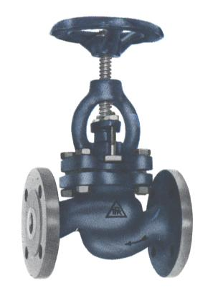

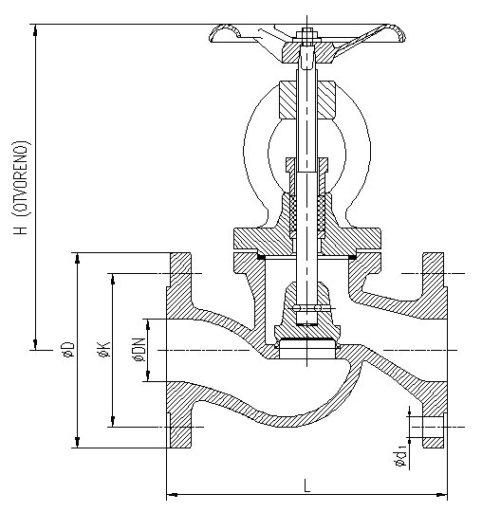
NAMJENA: VODA, PARA, ZRAK, INERTNI PLINOVI.
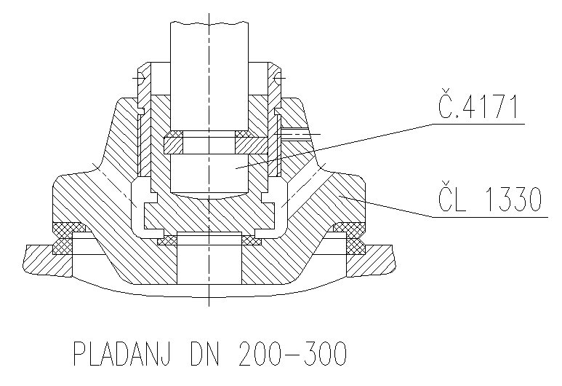
X15Cr13

GS-C25

PLADANJ DN 200-300

CONTENTS: WATER, STEAM, AIR, INERT GASES.

DN | L | H | øD | øK | ød₁ | n | masa  weight  kg
15 | 130 | 200 | 95 | 65 | 14 | 4 | 3,3
20 | 150 | 200 | 105 | 75 | 14 | 4 | 3,8
25 | 160 | 216 | 115 | 85 | 14 | 4 | 5,1
32 | 180 | 216 | 140 | 100 | 18 | 4 | 6,6
40 | 200 | 265 | 150 | 110 | 18 | 4 | 9,5
50 | 230 | 265 | 165 | 125 | 18 | 4 | 12,1
65 | 290 | 308 | 185 | 145 | 18 | 4 | 18,5
80 | 310 | 337 | 200 | 160 | 18 | 8 | 23,5
100 | 350 | 402 | 220 | 180 | 18 | 8 | 34
125 | 400 | 446 | 250 | 210 | 18 | 8 | 53
150 | 480 | 515 | 285 | 240 | 22 | 8 | 70
200 | 600 | 646 | 340 | 295 | 22 | 12 | 140
250 | 730 | 795 | 405 | 355 | 26 | 12 | 220
300 | 850 | 882 | 460 | 410 | 26 | 12 | 330

