PN 25/40 | STANDARDNA IZVEDBA  STANDARD DESIGN
KUĆIŠTE  BODY | GS-C25/ W.Nr. 1.0619  CAST STEEL GP240GH
UNUTARNJI DIJELOVI  INNER PARTS | NEHRĐAJUĆI ČELIK  STAINLESS STEEL
NAZIVNI OTVOR  NOMINAL DIAMETER | DN 15-200
NAZIVNI TLAK (bar)  NOMINAL PRESSURE | PN 25/40
TEMPERATURA  TEMPERATURE RANGE | DO 400⁰C  TO 400⁰C
SPAJANJE  CONNECTION | PRIRUBNICA DIN 2501  FLANGES
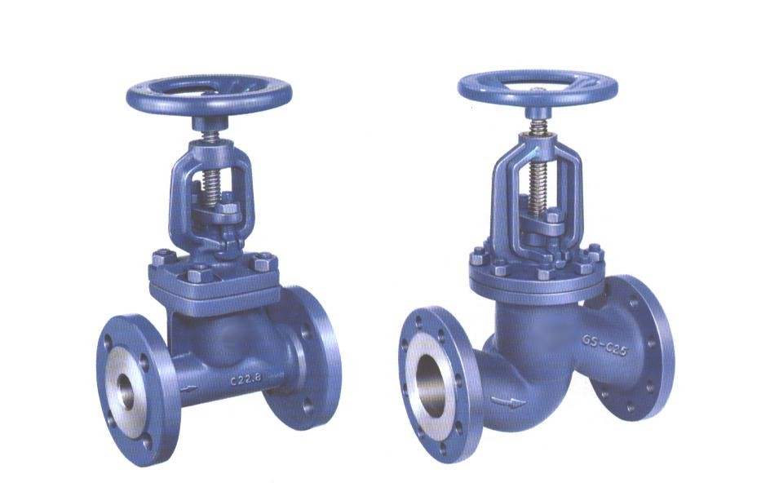

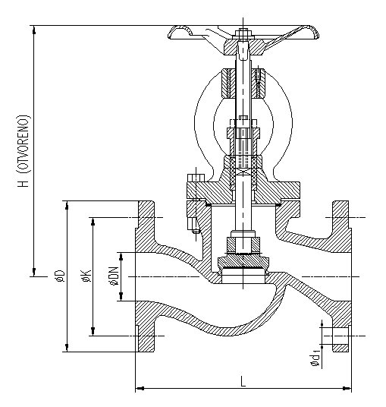

NAMJENA: VODA, PARA, ZRAK,
INERTNI PLINOVI.

CONTENTS: WATER, STEAM, AIR,
INERT GASES.

DN | L  25/40 | H  25/40 | øD  25/40 | øK  25/40 | ød₁  25/40 | n  25/40 | masa  weight  kg
15 | 130 | 153 | 95 | 65 | 14 | 4 | 4,8
20 | 150 | 187 | 105 | 75 | 14 | 4 | 5,8
25 | 160 | 187 | 115 | 85 | 14 | 4 | 6,6
32 | 180 | 244 | 140 | 100 | 18 | 4 | 10,2
40 | 200 | 244 | 150 | 110 | 18 | 4 | 14,6
50 | 230 | 287 | 165 | 125 | 18 | 4 | 14,8
65 | 290 | 335 | 185 | 145 | 18 | 8 | 27
80 | 310 | 370 | 200 | 160 | 18 | 8 | 36
100 | 350 | 445 | 235 | 190 | 22 | 8 | 51
125 | 400 | 500 | 270 | 220 | 26 | 8 | 78
150 | 480 | 536 | 300 | 250 | 26 | 8 | 106
200 | 600 | 634 | 360/375 | 310/320 | 26/30 | 12 | 165/182

