PN 25/40 | STANDARDNA IZVEDBA  STANDARD DESIGN
KUĆIŠTE  BODY |  | GS-C25/ W.Nr. 1.0619  CAST STEEL GP240GH
UNUTARNJI DIJELOVI  INNER PARTS |  | NEHRĐAJUĆI ČELIK  STAINLESS STEEL
NAZIVNI OTVOR  NOMINAL DIAMETER |  | DN 15-200
NAZIVNI TLAK (bar)  NOMINAL PRESSURE |  | PN 25/40
TEMPERATURA  TEMPERATURE RANGE |  | DO 400⁰C  TO 400⁰C
SPAJANJE  CONNECTION |  | PRIRUBNICA DIN 2501  FLANGES
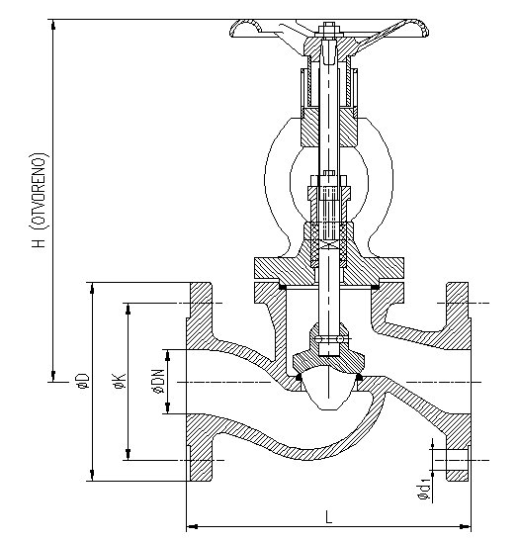

NAMJENA: VODA, PARA, ZRAK, INERTNI PLINOVI.

CONTENTS: WATER, STEAM, AIR, INERT GASES.

DN | L  25/40 | H  25/40 | øD  25/40 | øK  25/40 | ød₁  25/40 | n  25/40 | masa  weight  kg
15 | 130 | 240 | 95 | 65 | 14 | 4 | 6
20 | 150 | 240 | 105 | 75 | 14 | 4 | 6,5
25 | 160 | 270 | 115 | 85 | 14 | 4 | 8
32 | 180 | 270 | 140 | 100 | 18 | 4 | 11
40 | 200 | 341 | 150 | 110 | 18 | 4 | 20,5
50 | 230 | 341 | 165 | 125 | 18 | 4 | 20,5
65 | 290 | 405 | 185 | 145 | 18 | 8 | 28
80 | 310 | 457 | 200 | 160 | 18 | 8 | 55,4
100 | 350 | 491 | 235 | 190 | 22 | 8 | 58
125 | 400 | 569 | 270 | 220 | 26 | 8 | 79
150 | 480 | 639 | 300 | 250 | 26 | 8 | 105
200 | 600 | 775 | 360/375 | 310/320 | 26/30 | 12 | 165/195

